SOCS Comparison Practice: S-M Ratios in Europe and North America
Show all your work. Indicate clearly the methods you use, because you will be graded on the correctness of your methods as well as on the accuracy of your results and explanation.
A multinational corporation calculates the sales-to-marketing personnel ratio (S-M ratio), defined as the number of salespeople per marketing employee, for each of its branches. The histograms show the S-M ratios for the 52 branches in Europe and the 48 branches in North America during the 2025 fiscal year.
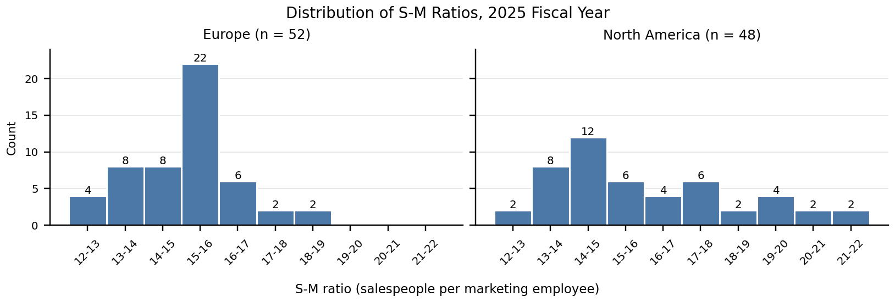
Region | n | Mean | SD | Min | Q1 | Median | Q3 | Max
Europe | 52 | 15.12 | 1.37 | 12.3 | 14.2 | 15.3 | 15.9 | 18.3
North America | 48 | 16.06 | 2.36 | 12.6 | 14.4 | 15.3 | 17.1 | 21.8
Summary statistics are calculated from the raw data. Extreme values: Europe — two smallest 12.3, 12.5; two largest 18.1, 18.3. North America — two smallest 12.6, 12.9; three largest 20.6, 21.3, 21.8.
Task (20 points): Compare the distributions of S-M ratios for the branches in Europe and North America. Address shape, outliers, center, and spread, justify your answers with appropriate calculations, and interpret your results in context.

